**Aim:** To study the Depth Estimation

**Objective:** To Capturing Frames form a depth camera creating a mask from a disparity map Masking a copy operation Depth estimation with normal camera

**Theory:**

1. Depth Map

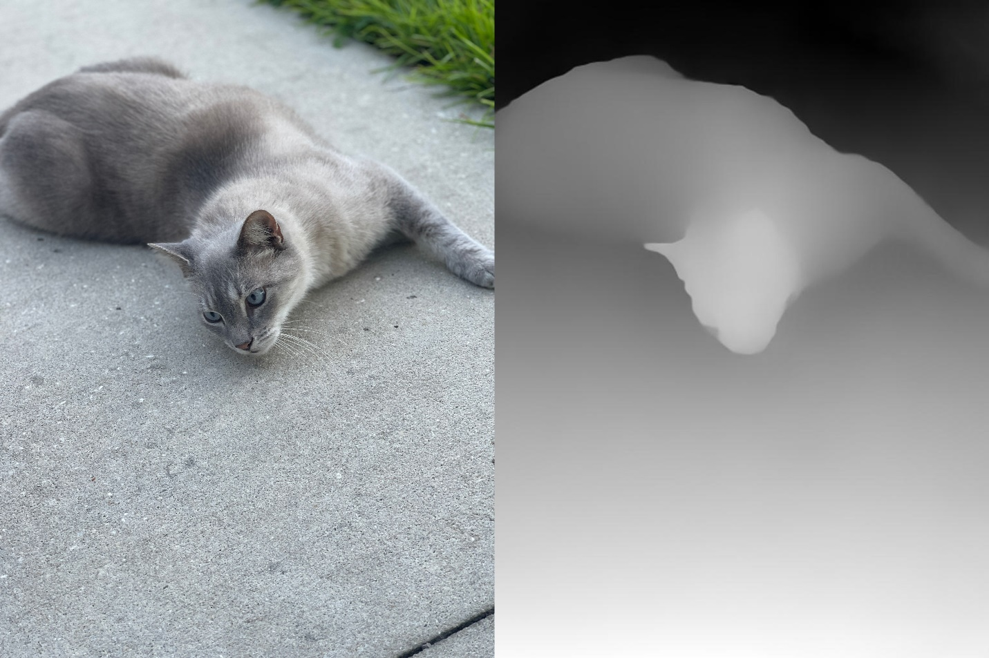

Fig.4.1 Depth map

In 3D computer graphics and computer vision, a depth map is an image or image channel that contains information about the distance from the viewpoint to the surface of scene objects. The term is related (and potentially similar) to depth buffer, Z-buffer, Z-buffering, and Z-depth. The "Z" in the latter term relates to the convention that the central axis of the camera's field of view is oriented along the camera's Z axis, rather than the absolute Z axis of the scene. Depth maps have many uses, including: Simulates the effect of uniform density translucent media in a scene, such as fog, smoke, or large amounts of water. However a single-channel depth map records the first observed surface, so it cannot be viewed or refracted through a transparent object, or displayed information about a surface reflected by a mirror. This can limit their use in accurately simulating depth of field and fog effects.

1. Point Cloud Map

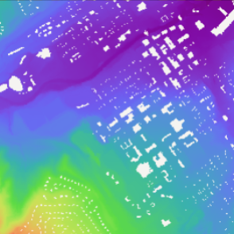A point cloud comprises discrete data points within a spatial context, potentially depicting a 3D structure or entity. Each point's location is defined by a specific set of Cartesian coordinates (X, Y, Z). These point clouds are typically generated through 3D scanning devices or photogrammetry software, capturing numerous points on object surfaces in their vicinity. Serving as the outcome of 3D scanning procedures, point clouds serve a variety of objectives. These encompass the creation of 3D computer-aided design (CAD) models for manufactured components, applications in metrology and quality assessment, as well as a wide array of uses in visualization, animation, rendering, and the customization of mass-produced items.

Fig.4.2 Point Cloud Map

1. Disparity Map

A disparity map is a visual representation of the differences in image pixel locations between two stereo images, revealing depth information. Its advantage lies in providing a means to perceive 3D depth from 2D images, aiding in tasks like object detection and scene reconstruction. However, disparity maps can be sensitive to lighting conditions and textureless areas, leading to inaccuracies in depth estimation. Despite these limitations, disparity maps are valuable tools for applications in robotics, augmented reality, and computer vision.

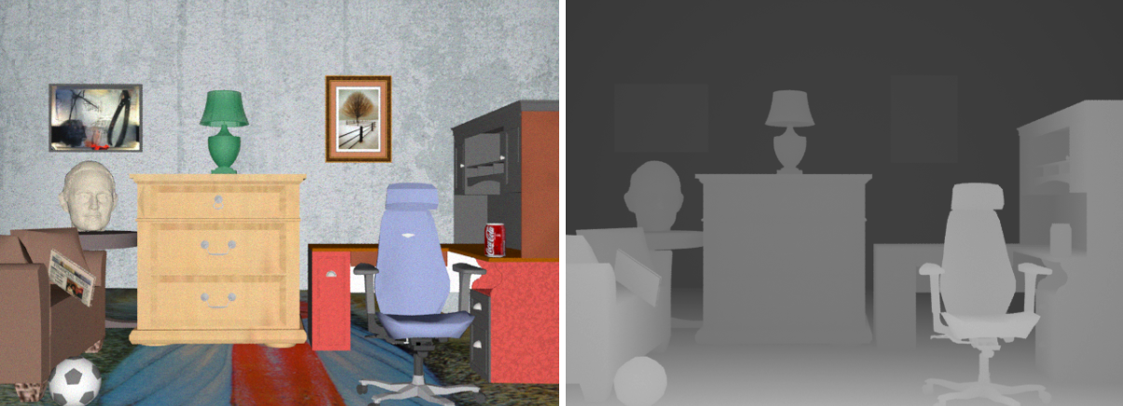

A valid depth mask

A valid depth mask is a binary image that indicates which pixels in the depth map have reliable depth information.It's obtained by thresholding the disparity values in the disparity map. Smaller disparities usually correspond to closer objects.A valid depth mask is important to exclude unreliable depth values from further processing.

Creating a Mask from a disparity map

To create a valid depth mask, you set a threshold range on the disparity values to identify regions with meaningful depth information.Pixels with disparities below the threshold are considered valid, while higher disparities are potentially erroneous.This mask ensures that you work with accurate depth information when combining it with other images.

Masking a Copy Operation

Masking involves applying the valid depth mask to select specific regions of the depth map.When performing a copy operation, you transfer the selected regions from the depth map to corresponding areas in the normal camera image.This operation creates a composite image that combines depth information with the appearance of the normal camera image.

Depth estimation with a normal camera

Estimating depth using a normal camera (monocular depth estimation) relies on various visual cues.These cues include size of objects (larger objects are usually closer), perspective (objects further away appear smaller), and texture gradients (dense textures imply proximity).Machine learning techniques, like convolutional neural networks, can also be used to predict depth from single images.

**Code:**

import cv2

import numpy as np

import matplotlib.pyplot as plt

# Load left and right images

left_image = cv2.imread('/content/WhatsApp Image 2023-08-22 at 8.12.00 PM.jpeg', cv2.IMREAD_GRAYSCALE)

right_image = cv2.imread('/content/WhatsApp Image 2023-08-22 at 8.13.19 PM.jpeg', cv2.IMREAD_GRAYSCALE)

# Stereo matching algorithm

stereo = cv2.StereoBM_create(numDisparities=64, blockSize=15)

# Compute disparity map

disparity_map = stereo.compute(left_image, right_image)

# Convert disparity map to depth map

focal_length = 0.5 # Focal length of the camera (adjust as needed)

baseline = 0.1 # Distance between the two cameras (adjust as needed)

depth_map = (baseline * focal_length) / (disparity_map + 1e-5)

# Normalize depth map for visualization

depth_map_normalized = cv2.normalize(depth_map, None, alpha=0, beta=255, norm_type=cv2.NORM_MINMAX, dtype=cv2.CV_8U)

# Apply colormap for visualization

depth_colormap = cv2.applyColorMap(depth_map_normalized, cv2.COLORMAP_JET)

# Display the depth map using matplotlib

plt.figure(figsize=(10, 5))

plt.imshow(cv2.cvtColor(depth_colormap, cv2.COLOR_BGR2RGB))

plt.axis('off')

plt.title('Depth Map')

plt.show()

**Output:**

**input image:**

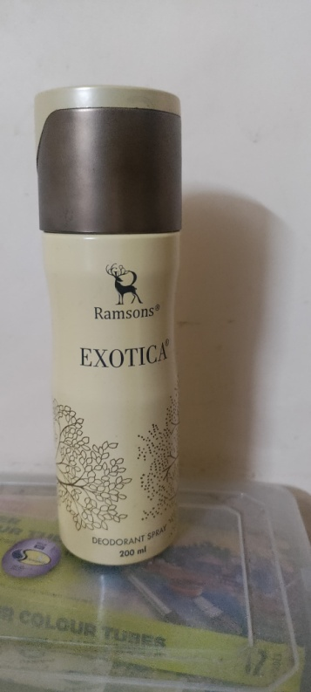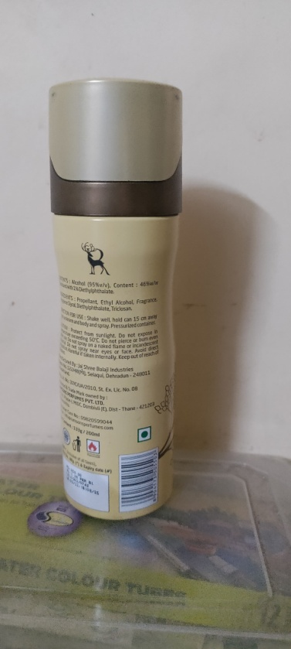

**Output image :-**

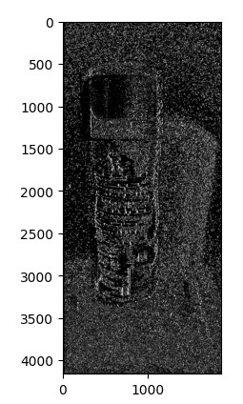

**Conclusion:**

In this experiment, depth was estimated by combining a depth camera with a standard camera. The depth mask was made using depth maps from the depth camera, and it served as a guide for masking and duplicating the depth and regular camera pictures together. The study also demonstrated the feasibility of determining depth using monocular approaches using a conventional camera. Overall, the experiment highlighted the importance of depth information in computer vision and showed how it may enhance visual effects and picture understanding.